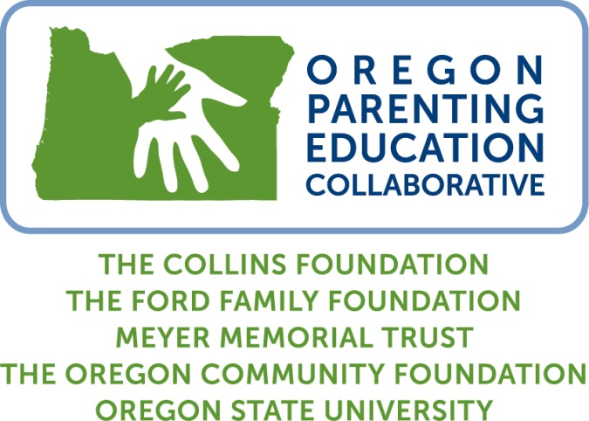

Oregon Parenting Education Collaborative
2017-2018 Programming Grants Renewal Application

Proposals must be submitted by February 1, 2017 (postmark deadline) to:

Early Childhood Program

The Oregon Community Foundation
1221 SW Yamhill, Suite 100
Portland, OR 97205

Questions may be directed to Mary Louise McClintock at 503.227.6846 or mlmcclintock@oregoncf.org.

The Oregon Parenting Education Collaborative (OPEC) is a multi-year, statewide grant program launched in 2010 and funded by The Oregon Community Foundation, The Collins Foundation, The Ford Family Foundation, and the Meyer Memorial Trust. The initiative provides support for expansion and delivery of parenting education programs and for efforts to develop and strengthen regional parenting education infrastructure. For more information on OPEC, please visit www.orparenting.org.

Programming Grants Renewal Application

This Request for Proposals seeks renewal applications from current OPEC parenting education programming grantees. The renewal process provides an opportunity for a progress report to ensure that projects are on track and that objectives are being met. Renewal grant review will include a phone conversation and/or site visit with Collaborative representatives. Awards are based on satisfactory progress to date.

The cycle of grants has two focuses:
- Expansion of access to best practice parenting education programs in regions of Oregon not yet served by a parenting education Hub
- Development and expansion of partnerships between providers of parenting education and the health care community, including testing of models for delivery of programs through such partnerships

Applicant Information

Eligible organizations: Nonprofit 501(c)(3) organizations or public agencies, school districts, and community colleges. Organizations that received funding through the Oregon Parenting Education Collaborative for 2016-2017 are eligible under this RFP.

Funding amount: Renewal programming grantees can apply for the amount specified the grant award cover letter from OPEC.

Application timeline:
  - Deadline (postmark) – February 1, 2017
  - Proposal review through April
  - Award notification - late May
  - Grant year begins - July 1, 2017

Expectations of Funded Projects

- Cooperate with the initiative evaluator to collect and provide the needed data and information on a quarterly basis from parents, collaborators, and volunteers involved with the project. Grantees will be required to use the Parenting Skills Ladder with each family following each parenting education series or workshop, which is currently available in multiple languages; OPEC will work with grantees to ensure culturally appropriate use of the tool.
- Complete detailed, semi-annual financial reports.
- Commit to share program-related experiences and findings with all OPEC grantees and funders and the evaluator.
- Attend (at least two representatives from your site) annual fall networking conferences sponsored by OPEC.
- Participate in a mid-year and end-of-year conference call with Oregon State University regarding progress to-date as well as technical support needs.
- Annual site visit from the funders and/or evaluators.

Components of the Proposal

Please submit two unbound copies of your completed proposal. Faxes or emailed documents will not be accepted. All proposals must include the following components, in the order listed below.

- Application Summary Form. [Word Template] (This form is not part of your three-page proposal.)
- Program Narrative. (no more than 3 pages in length, minimum 12-point font, single spaced)
Please respond to the following questions:
For all applicants:
- Summarize your parenting education programming efforts since July 1, 2016, including the number and types of programs offered and the number of parents reached. Note: OSU will provide the funders with an update on your programming numbers and other results through December 31, 2016.
- Overall, describe how your parenting education programming has expanded or changed as a result of the OPEC funding thus far. This may include the addition of facilitators, curricula, etc.
- Describe how program implementation is going and how your project will expand the availability of parenting classes and/or home visits for the families you propose to reach over the three-year grant period. How many parents will you reach each year? Include a description of recruitment and retention strategies, including outreach, events, incentives, etc.
- If your organization has been involved in any local or regional system-building efforts, such as an Early Learning Hub and/or Coordinated Care Organization (CCO), a parenting education Hub or (in Multnomah County) the Ready for Kindergarten Collaborative, please describe how you are participating and contributing to planning efforts.
- Have other collaborative partnerships evolved as a result of your project? If so, please describe.
- What are strengths and areas of concern for your funded project? How will you build on the strengths and address the concerns?
- Identify any unexpected outcomes of the project, positive, and/or negative.
- Provide an update on your plans for sustaining the project beyond the grant period.
- Provide a brief budget narrative describing the proposed use of grant funds in years two and three and explain any variations in the approved year one (2016-2017) budget. Eligible expenses include: program delivery expenses (facilitators, space, child care, food, transportation, and parent incentives); purchase of curriculum and other materials; facilitator training; program coordination.
For applicants from regions served by an OPEC parenting education Hub:
- Describe how the partnership between parenting education providers and the health care sector is progressing.
- How are your efforts strengthening collaboration between the parenting and health care sectors and how are you reaching parents who are not yet served through other parenting education services?

- Attachments. (Not included as part of the three-page narrative document.)
- Proposed three-year project budget, identifying revenue (cash and in-kind) sources and expenditures in a detailed line-item format.
  - Grants may not exceed $25,000 per year. Annual renewals are required and awarded based on satisfactory prior year achievements.
  - Include the total proposed three-year cost of the parenting education program.
  - A minimum 25% funding match is required.
- Two most recent years of financial statements for the grantee organization.
- Organization budget for the current fiscal year.
- List of Board of Directors, with affiliations and phone numbers.
- Copy of IRS 501(c)(3) tax determination letter.
- Work Plan for 2017-2018 [Word Template]

You may include letters of support only if they are related to the proposed project and outline partner commitment and responsibilities.

Approved Curricula for this Project

Curricula should be selected from the following list, but exceptions can be made in cases where the applicant organization can 1) make a case that there is not an evidence-based curriculum available and suitable for their target population and 2) present documentation showing at least two years of outcomes from the proposed alternative curriculum.

- The Incredible Years http://www.incredibleyears.com/program/parent.asp
- Make Parenting a Pleasure, Parenting: The First Three Years, Haga de la Paternidad un Placer, Parenting Now! http://www.parentingnow.org/curricula_and_training.html
- Nurturing Parenting http://nurturingparenting.com/ecommerce/category.i?cmd=searchlist [information about variations for cultural populations can be found in this curriculum’s Multi-Cultural Parenting Guide http://nurturingparenting.com/shop/p/7/Multicultural%20Parenting%20Guide%20(MCG)]
- Parents as Teachers http://www.parentsasteachers.org/training/training-gateway
- Second Step http://www.cfchildren.org/
- Abriendo Puertas http://www.familiesinschools.org/abriendo-puertas-opening-doors/
- Effective Black Parenting http://www.ciccparenting.org/EffBlackParentingDesc.aspx
- Positive Indian Parenting http://www.nicwa.org/success/positive_indian_parenting.asp
- Parenting A Second Time Around (PASTA) (curriculum for grandparents) http://www.human.cornell.edu/pam/outreach/parenting/programs/parentingasecondtimearound.cfm
- Parenting Inside Out http://www.parentinginsideout.org/

Applicants may also find other appropriate evidence-based curricula on the following national registries:
SAMHSA’s National Registry of Evidence-based Programs and Practices (NREPP)
http://www.nrepp.samhsa.gov/
Office of Juvenile Justice and Delinquency Prevention (OJJDP) Model Programs Guide
http://www.ojjdp.gov/mpg/
Home Visiting Evidence of Effectiveness
http://homvee.acf.hhs.gov/

Definitions and Terms

Parenting education: The National Parent Education Network offers the following definition of parenting education: “a process that involves the expansion of insights, understanding and attitudes and the acquisition of knowledge and skills about the development of both parents and of their children and the relationship between them.” (http://www.npen.org/about/background.html)

Evidence-based: A program is “judged to be evidence-based if (a) evaluation research shows that the program produces the expected positive results; (b) the results can be attributed to the program itself, rather than to other extraneous factors or events; (c) the evaluation is peer-reviewed by experts in the field; and (d) the program is “endorsed” by a federal agency or respected research organization and included in their list of effective programs.” (Evidence-based programs: An overview, University of Wisconsin-Madison and University of Wisconsin-Extension, October 2007)

Culturally-specific organization:
- A majority of clients are from a specific cultural community.
- The organization is led and staffed primarily by those sharing the racial or cultural identity of the community served.
- The organizational or program environment is culturally focused and identifiable by the consumer as such.
- There is established and successful community engagement and involvement with the culturally-specific community being served.
(The elements of the definition above were adapted from Communities of Color in Multnomah County: An Unsettling Profile, Coalition of Communities of Color and Portland State University, 2010 http://www.coalitioncommunitiescolor.org/docs/AN%20UNSETTLING%20PROFILE.pdf, and from the definition used by the Portland Children’s Levy in its grantmaking.)

Cultural competence: “the ability of individuals and systems to respond respectfully and effectively to people of all cultures, classes, races, ethnic backgrounds, sexual orientations, ability statuses, and faiths or religions, in a manner that recognizes, affirms, and values the worth of individuals, families, tribes, and communities, and protects and preserves the dignity of each. Cultural competence is a continuous process of learning about the differences of others and integrating their unique strengths and perspectives into our lives.” (Child Welfare League of America)
Culturally-adapted curriculum: “the examples used to teach the main lessons are transformed to respect the target culture’s practices” (Dalla, R. L., Defrain, J., Johnson, J., & Abbott, D. A. (2009). Strengths and challenges of new immigrant families: Implications for research, education, policy, and service. Lexington Books)
Culturally-specific curriculum: “the philosophy and underlying assumptions of the program integrate the target group’s values and beliefs” (Dalla, R. L., Defrain, J., Johnson, J., & Abbott, D. A. (2009). Strengths and challenges of new immigrant families: Implications for research, education, policy, and service. Lexington Books)

