Dr. John Wm. and Betty Long Unruh Fund
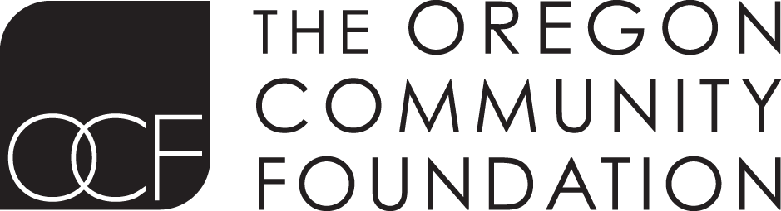
Grant Application

Date

Organization Name
Alternate name/acronym
Address
City |  |  |  |  |  |  | State |  |  |  | ZIP
Website |  |  |  |  |  |  | General Email
Phone # |  |  |  |  |  |  | Fax #
Executive Director or Board Chair |  |  |  |  |  |  |  |  |  |  | Prefix (Mr., Ms., etc.)
First Name |  |  |  |  |  |  |  | Last Name
Title |  |  |  |  |  |  |  | E-Mail
Contact Person if different |  |  |  |  |  |  |  |  |  |  | Prefix (Mr., Ms., etc.)
Name |  |  |  |  |  |  |  | Title
Phone |  |  |  |  |  |  |  | E-Mail
Mission
Employer ID number (EIN) |  |  |  |  |  |  |  |  |  |  | Year established
Number of paid employees |  |  |  |  |  |  | FTE |  |  |  | Number of volunteers
Number of board members |  |  |  |  |  |  |  |  |  |  | Number of board meetings per year
Current annual budget
Please identify your five largest donors and their amounts. (Contributors include specific individuals, agencies, businesses, foundations, or other groups.)
Project Budget |  |  |  |  | Total project budget |  |  |  |  | Total requested
Project Description
(one sentence)
Provide a brief description of how your organization intends to use the requested amount.

I certify that the above information is correct and that I am authorized by the governing board of this organization to submit this information to OCF. Additionally, I certify that (1)this organization is in good standing under IRC 501(c)(3) and is further classified as a public charity pursuant to section 509(a)(1) or 509(a)(2) OR (2)this organization qualifies for tax exempt status as a public school or government agency.
Name (printed) of head of organization |  | Title
Signature of head of organization (director or board chair) |  | Date

Required Materials: If submitting hard copies, please submit them unstapled, unbound, and two-sided.
Application Form
Project budget outlining how the grant funds will be used
Organization budget for current year (one page)
List of board of directors with affiliations and phone numbers
Organization 501(c)(3) tax determination letter

Please submit electronically or by mail to:
The Oregon Community Foundation
Donor Relations Department (Unruh Fund)
1221 SW Yamhill St. Ste. 100
Portland, OR 97205-2108
unruhfund@oregoncf.org

