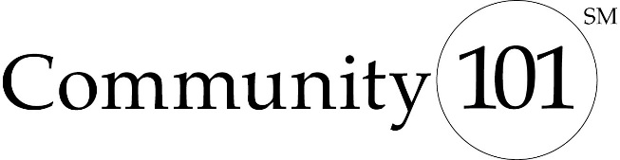

Grant Evaluation Form

Your report is due December 7, 2018.
You may re-create this form on your computer or download it from www.oregoncf.org/c101 |  |  |  | Date:

Organization Name

Contact Person / Title

Address

Phone / E-mail
Amount of Grant |  | Community 101 School: | «School_»

If completing this form electronically, please delete extra space in the boxes after entering your information. Answers should be concise, but if you need to continue to a third page, feel free to do so.
Describe the specific objectives and activities outlined in your proposal and the actual results to date.

Based on your answer above, how would you describe the project’s measurable impact so far on the
people you serve? How many people were served by this grant?

What has been the project’s measurable impact to date on your organization? Has the grant (1) helped to attract new funding from the community, (2) increased collaboration with other organizations, (3) increased volunteer involvement? How has your organization changed as a result of this project?

Has this project been modified since you received the grant from the students? Have the actual costs been consistent with the estimates? If not, what were the reasons for the significant variations?

If you feel your project has been successful, what factors contributed to this? If the project was less successful than you hoped, what do you think contributed to that?

Please describe your experience with Community 101 students and the program overall.

The positive impact of a project is not always easy to communicate via measurable results. If this is true of your project, please share with us a story that illustrates the impact. We also welcome photo or video submissions. Please attach or send them electronically to kwhitney@oregoncf.org and indicate if they cannot be shared publicly.

Signature / Title of Person Completing This Form
Date Form Completed
You may email this form to: kwhitney@oregoncf.org
Questions? Please call Kim Whitney at 503-227-6846.

