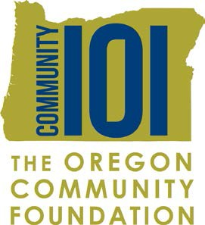

Student Body/Community Survey

Our Community 101 group in (insert name of class) is helping to improve our
community by awarding grants and volunteering. Our Community 101 group has $5,000 to give to nonprofit organizations that inspire change and encourage potential in one of four areas: education, the promotion of healthy families, access to the arts or environmental enhancement. We’d like your input in determining a focus for this funding.

What issues facing you and your community (school, neighborhood, family, and friends, whichever you choose) do you think have the greatest need?

Please choose a total of five issues and rank them in order from 1 to 5, with “1” being the most important to you and “5” being of least concern. If you think none of these is the number one problem, please check “Other” and tell us what you think it should be.

Rank | What’s important to you? | Rank | What’s important to you?
 | Alcohol abuse |  | Poor health care
 | Decreasing voter turnout |  | Discrimination
 | Teen pregnancy |  | Mental health (anxiety, depression, etc.)
 | Stress |  | Illiteracy
 | Lack of self esteem |  | Inadequate housing
 | Racism |  | Homelessness
 | Suicide |  | Civic engagement
 | Bullying |  | Drug abuse
 | Healthy relationships |  | Juvenile crime
 | Children living in poverty |  | Lack of community involvement
 | Lack of recreational facilities / programs |  | Lack of volunteerism
 | Services for the disabled |  | Domestic violence
 | Child abuse |  | Services for immigrants and refugees
 | Sexual assault |  | Transportation
 | Services for the elderly |  | Environmental Issues
 | Violence in schools |  | Hunger
 | Social justice |  | Other:
 | Lack of arts and music |  | Other:
 | Diversity and inclusion |  | Other:

