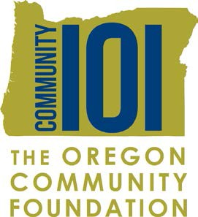

2018-2019
Community 101 Mission Statement

School: Date: ______________________________
Submitted by: Teacher: _______________________________
Name of funder(s): ____________________________________________________________________
_____________________________________________________________________________

Mission statement: ____________________________________________________________________________
______________________________________________________________________________________________
______________________________________________________________________________________________
______________________________________________________________________________________________
______________________________________________________________________________________________
______________________________________________________________________________________________
______________________________________________________________________________________________
______________________________________________________________________________________________

Important! Email the Request for Funds letter, with your mission statement, by:
November 9, 2018

Kim Whitney: kwhitney@oregoncf.org

