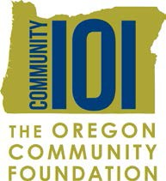

Grant Application Score Sheet

Students can use this form to evaluate nonprofit grant applications – they can add additional questions, too! Once a student completes this form, the entire group can discuss the pros and cons of each application. This is a launching point for the decision-making process.

Nonprofit Organization:
Project:
Questions | Your Score Possible score:10/100 total
1. Project promotes healthy development of young people and provides youth with a safe environment.
2. Project is viable and/or realistic; has realistic plan, timeline and budget.
3. Project provides opportunities for young people to give back to the community in meaningful ways.
4. Project involves youth and adults in project planning, grant writing and implementation.
5. Project brings together diverse people and organizations in proposal and project development.
6. Project develops skills in young people.
7. Project promotes positive relationships between youth and adults.
8. Project shows creativity and innovation.
9. Project is a vehicle for positive social change.
10. Project has elements of sustainability.
Total
Your Name:
Comments:

