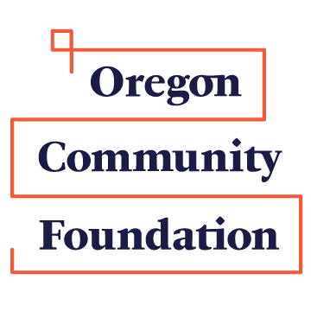
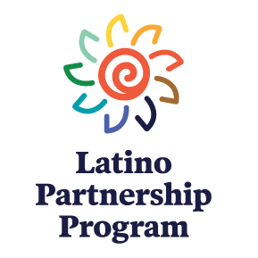
Grant Application Information for
The Southern Oregon Latino Partnership Program’s Small Grants

Program Details
The Southern Oregon Latino Partnership Program of The Oregon Community Foundation (OCF) supports projects and activities that address one of these three priorities:
- Projects and activities that support Latino leadership and leadership development
- Forge ties between Latino and non-Latino communities and individuals
- Projects that benefit Latino youth and families, especially projects that address education challenges and gaps

Grants, which range from $1,000 to $5,000 each, are awarded annually each fall.

Eligibility
- Applicant organizations must be based in and serving residents of Jackson, Josephine, Klamath or Lake Counties.
- Applications are accepted from schools or nonprofits organizations that have been in existence for at least one year. Individuals are not eligible.
- Fiscal sponsors are permitted.
- The program is open to both Latino-led organizations and non-Latino led organizations that will be serving Latinos with the project or activity for which they are applying.
- Only projects that will occur after the funding decision in November and that will be completed within twelve months of the decision will be considered.
- An organization may submit only one LPP application per year.

Review Criteria
Applications will be reviewed first by the Southern Oregon Latino Partnership Program advisory committee and then by the OCF Board and will be judged against the following criteria:
- The project meets one of the three funding priorities (above).
- The project meets a need.
- The community is engaged in the work of the applicant organization.
- The applicant organization has a track record of effective work.
- The strongest applications will show evidence of additional support (beyond the OCF grant) for the proposed project, be that other cash or in-kind goods or services.

Deadlines
Applications are due by 5:00 p.m. on September 15 for OCF decisions in October or November board meeting. This is not a postmark deadline. Grant applications must be received by the due date in order to be considered.

To Apply
An application packet consists of:
- a completed Southern Oregon Latino Partnership Program Grant Application Form,
- a project budget, and
- for new applicants only, a copy of the organization’s current IRS 501(c)3 determination letter.

To apply please mail or hand-deliver one copy of the application packet to:
The Southern Oregon Latino Partnership Program
The Oregon Community Foundation
818 West Eighth Street
Medford, OR 97501
Applications are also accepted by email at slapierre@oregoncf.org

Post-Award Requirements
- Grant recipients will be required to credit The Oregon Community Foundation.
- While written reports are not required for LPP grants, grantees may be asked to meet with the Southern Oregon LPP advisory committee and/or OCF staff to discuss their projects and results
Questions
It you have questions, please contact Roberto Franco at 503-227-6846 or rfranco@oregoncf.og or the OCF Medford office at 541-773-8987.

