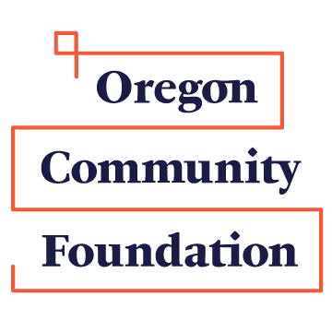
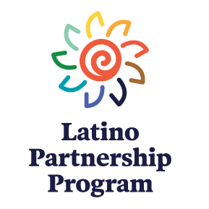

The Southern Oregon Latino Partnership Program Grant Application Form
Before completing this application, please read the Grant Application Information document to make certain that you understand the application requirements and process.
Application deadline is September 15.

Organization
Applicant organization Tax ID #
Address, City, State, Zip
Telephone Fax Website
Contact name Contact email
$ | $
Organization’s total expenses last year Organization’s total revenues last year
Previous OCF Grants. List OCF grants in the past three years:
Amount | Purpose

Grant Project
One-sentence purpose of grant

County or counties in which this project will take place

Number of people who will be served by the project, ages of people served, approx. % of people served who are Latino

Total project budget Grant request
$ | $

Application Questions (No more than two pages)
Brief description of your organization, including your mission and accomplishments

Brief description of the proposed project, including timeline, location, target audience

Which of the Southern Oregon Latino Partnership Program’s three funding priorities does your project address and how?

What are the goals of your project, and how will you measure success?

Project partners and roles, if any.

Applicant’s statement: If awarded this grant, I agree to use the funds as indicated in this application. I further agree that if requested, may meet with the Southern Oregon LPP advisory committee and/or OCF staff to discuss their projects and results. I am authorized by my organization to submit this application.

Name Signature Date
After completing this Grant Application Form, please attach a budget for your project, showing both expenses and income. If you are a first-time applicant, please also attach a copy of your organization’s current IRS 501(c)3 determination letter.

